No Canadian “Charity” for the Israeli Military!!
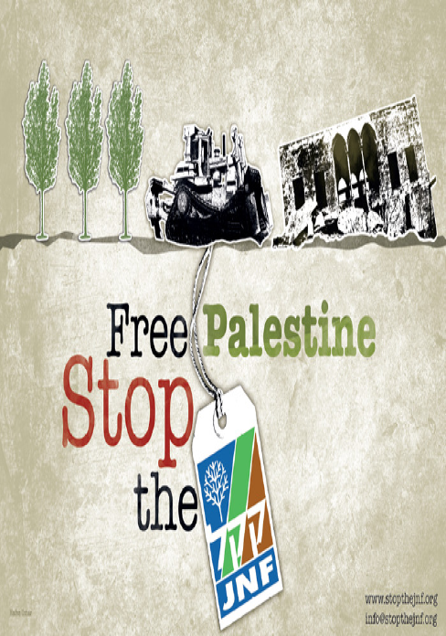
On June 9, the Jewish National Fund JNF Pacific Region is holding its Negev Gala Dinner. Palestinian supporters in Vancouver will be picketing the event to protest not only the JNF's well-documented racist policies but also this year's honourees, the "Israel Defense Forces". It seems the JNF has given up on their attempts at greenwashing their ethnic cleansing of Palestinians and are now openly embracing Israeli military aggression. Lets mark the 65th anniversary of the Palestinian Nakba by protesting the JNF and the Canadian government’s refusal to even question the JNF’s charitable status, as revealed in recently released documents.
Stop the JNF!
Sunday, June 9, 4-6 pm
Gather across the street from Schara Tzedeck Synagogue, 3476 Oak St. (at 19th), Vancouver
Organized by: Canada Palestine Association
http://www.cpavancouver.org/
Endorsed by: Boycott Israeli Apartheid Campaign, Gaza’s Ark, Independent Jewish Voices-Vancouver, Samidoun Prisoner Solidarity Network, Solidarity for Palestinian Human Rights-UBC

