Picket the JNF! Mark Palestinian Land Day!
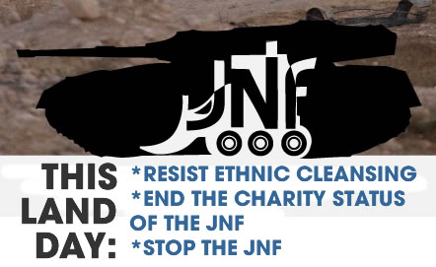
April 6, 2014, 5 pm, Four Seasons Hotel (W. Georgia and Howe St.), Vancouver, B.C.
On April 6, 2014, the Jewish National Fund JNF Pacific Region is holding its annual “Negev Gala Dinner”. However, the Bedouin village of Al Araqib in the Negev has been destroyed 62 times by Israeli and JNF paramilitary forces (as of Nov, 2013), but the Palestinians of the village return time and time again to rebuild. March 30th is also Palestinian Land Day and the villagers of Al Araqib are a moving example of the Palestinians’ enduring attachment to their land. Join us April 6th to show support for the Palestinian struggle!!
Organized by: Canada Palestine Association http://www.cpavancouver.org/ Endorsed by: Boycott Israeli Apartheid Campaign, Canadian Boat to Gaza, Independent Jewish Voices-Vancouver

Picket the JNF! Mark Palestinian Land Day!
April 6, 2014, 5 pm, Four Seasons Hotel (W. Georgia and Howe St.), Vancouver, B.C.
On April 6, 2014, the Jewish National Fund JNF Pacific Region is holding its annual “Negev Gala Dinner”. However, the Bedouin village of Al Araqib in the Negev has been destroyed 62 times by Israeli and JNF paramilitary forces (as of Nov, 2013), but the Palestinians of the village return time and time again to rebuild. March 30th is also Palestinian Land Day and the villagers of Al Araqib are a moving example of the Palestinians’ enduring attachment to their land. Join us April 6th to show support for the Palestinian struggle!!
Organized by: Canada Palestine Association http://www.cpavancouver.org/ Endorsed by: Boycott Israeli Apartheid Campaign, Canadian Boat to Gaza, Independent Jewish Voices-Vancouver

Picket the JNF! Mark Palestinian Land Day!
April 6, 2014, 5 pm, Four Seasons Hotel (W. Georgia and Howe St.), Vancouver, B.C.
On April 6, 2014, the Jewish National Fund JNF Pacific Region is holding its annual “Negev Gala Dinner”. However, the Bedouin village of Al Araqib in the Negev has been destroyed 62 times by Israeli and JNF paramilitary forces (as of Nov, 2013), but the Palestinians of the village return time and time again to rebuild. March 30th is also Palestinian Land Day and the villagers of Al Araqib are a moving example of the Palestinians’ enduring attachment to their land. Join us April 6th to show support for the Palestinian struggle!!
Organized by: Canada Palestine Association http://www.cpavancouver.org/ Endorsed by: Boycott Israeli Apartheid Campaign, Canadian Boat to Gaza, Independent Jewish Voices-Vancouver

Picket the JNF! Mark Palestinian Land Day!
April 6, 2014, 5 pm, Four Seasons Hotel (W. Georgia and Howe St.), Vancouver, B.C.
On April 6, 2014, the Jewish National Fund JNF Pacific Region is holding its annual “Negev Gala Dinner”. However, the Bedouin village of Al Araqib in the Negev has been destroyed 62 times by Israeli and JNF paramilitary forces (as of Nov, 2013), but the Palestinians of the village return time and time again to rebuild. March 30th is also Palestinian Land Day and the villagers of Al Araqib are a moving example of the Palestinians’ enduring attachment to their land. Join us April 6th to show support for the Palestinian struggle!!
Organized by: Canada Palestine Association http://www.cpavancouver.org/ Endorsed by: Boycott Israeli Apartheid Campaign, Canadian Boat to Gaza, Independent Jewish Voices-Vancouver

